**Automated LPG Usage and Safety Monitoring System Using Machine Learning & Smart Kitchen**

Dr. Anjaneya G

Assistant Professor

Mechanical Engineering

R.V COLLEGE OF ENGINEERINGBengaluru, Karnataka, India

[anjaneyag@rvce.edu.in](mailto:anjaneyag@rvce.edu.in)

Shreyash Anant Mithare  
Electronics and Communication Engineering  
R.V COLLEGE OF ENGINEERINGBengaluru, Karnataka, India

[shreyasham.ec23@rvce.edu.in](mailto:shreyasham.ec23@rvce.edu.in)

Jishnu Pradeep  
Electronics and Communication Engineering  
R.V COLLEGE OF ENGINEERINGBengaluru, Karnataka, India

[jishnupradeep.ec22@rvce.edu.in](mailto:jishnupradeep.ec22@rvce.edu.in)

Nagaprasad Naik  
Computer Science and

Engineering  
R.V COLLEGE OF ENGINEERINGBengaluru, Karnataka, India

[nagaprasadnaik.cs23@rvce.edu.in](mailto:nagaprasadnaik.cs23@rvce.edu.in)

Prajwal M S  
Electronics and Communication Engineering  
R.V COLLEGE OF ENGINEERINGBengaluru, Karnataka, India

[prajwalms.ec22@rvce.edu.in](mailto:prajwalms.ec22@rvce.edu.in)

Manoj Kumar B V  
Computer Science and

Engineering  
R.V COLLEGE OF ENGINEERINGBengaluru, Karnataka, India

[manojkumarbv.cs23@rvce.edu.in](mailto:manojkumarbv.cs23@rvce.edu.in)

*Abstract*— Liquefied Petroleum Gas (LPG) is a widely used fuel for domestic and commercial cooking, but its improper handling can lead to severe safety hazards such as gas leaks and fire accidents. This project presents an Automated LPG Usage and Safety Monitoring System that integrates Machine Learning (ML) and Smart Kitchen technologies to enhance safety, optimize gas consumption, and provide real-time monitoring.

The system employs Internet of Things (IoT) sensors to detect gas leakage, monitor LPG levels, and track usage patterns. In case of a gas leak, the system automatically triggers safety mechanisms, including turning on exhaust fans, opening smart windows, and sending real-time alerts via mobile notifications to users and emergency contacts. Additionally, an AI-powered assistant offers personalized cooking recommendations based on gas image uploaded.

Data collected from the sensors is stored and processed using cloud-based analytics, ensuring remote monitoring and control via a dedicated mobile application. The integration of smart kitchen appliances with the LPG system enhances convenience while maintaining safety standards. This intelligent and automated approach significantly reduces the risk of LPG-related accidents, promotes energy efficiency, and improves user experience in modern kitchens.

Keywords—IoT, Smart Kitchen, LPG Monitoring

# Introduction

Liquefied Petroleum Gas (LPG) is widely used in modern kitchens, but leakage or improper handling can pose serious safety risks. Our proposed Automated LPG Usage and Safety Monitoring System & Smart Kitchen enhances safety and convenience using IoT-based technologies. A load cell continuously monitors the LPG cylinder’s weight, sending timely refill notifications when it drops below a predefined threshold. A gas sensor detects leakage and triggers real-time alerts via the Blynk platform, while automatically opening windows to prevent hazards.

The system integrates smart kitchen functionalities using Sinric Pro, enabling voice-controlled appliance operation via Amazon Alexa and Google Home. Additionally, the Recipe-Lens feature leverages computer vision and NLP to generate personalized recipes from food images, providing step-by-step cooking instructions. By combining real-time monitoring, automated safety mechanisms, and AI-powered assistance, this system ensures a secure, efficient, and modern kitchen experience.

# Problem Statement

*Unmonitored LPG Consumption: Users are often unaware of how much gas remains in the cylinder, leading to unexpected depletion and disruption in cooking activities. Manual checking methods are inconvenient and unreliable.*

*Gas Leakage Risks: Undetected gas leaks can lead to fire hazards, explosions, and health issues due to inhalation of harmful gases. Traditional gas sensors only trigger audible alarms, which may go unnoticed if no one is present in the kitchen.*

*Lack of Automated Safety Measures: Existing systems do not take corrective actions, such as opening windows for ventilation, in case of a gas leak. Immediate response mechanisms are essential to prevent accidents.*

*Limited Smart Home Integration: Most LPG monitoring systems are not integrated with IoT-based platforms for remote alerts and smart home control. Users lack the convenience of voice-controlled kitchen operations through platforms like Amazon Alexa and Google Home.*

*Need for a Smart and Automated Solution: A system is required that can automatically monitor LPG levels, detect leaks, send alerts, and take preventive measures. The solution should be cost-effective, scalable, and easy to integrate into modern kitchens.*

*Limited Recipe Discovery and Personalization: Many home cooks struggle to find recipes that match their available ingredients or skill level. Current solutions often require manually searching through extensive databases, which can be time-consuming and overwhelming. There is a need for an intelligent, easy-to-use system that provides personalized cooking instructions based on the ingredients available and the user’s preferences.*

# Objectives

LPG Level Monitoring: A load cell continuously tracks the LPG cylinder's weight, sending automated refill alerts to ensure uninterrupted usage.

Gas Leakage Detection & Prevention: A gas sensor detects leaks, triggering real-time alerts via Blynk and automatically opening windows for ventilation.

Smart Home Integration: Sinric Pro enables voice-controlled gas monitoring via Amazon Alexa and Google Home, allowing remote operation.

Enhanced Safety Measures: Emergency alerts (SMS, mobile notifications), a buzzer, and LED indicators provide immediate hazard warnings.

Fire & Human Presence Detection: A fire sensor detects kitchen fires, while a presence sensor ensures gas usage only when an adult is present.

Cost-Effective & Scalable: A low-cost, energy-efficient IoT solution suitable for households and commercial kitchens, ensuring ease of installation.

Food Image Analysis & Recipe Generation: Deep learning identifies ingredients, estimates quantities, and generates personalized, step-by-step recipes based on user skill level and preferences.

AI-Powered Recipe Recommendations: Machine learning suggests recipes based on dietary preferences, cooking history, and available ingredients, enhancing user experience.

# Hardware Implementation

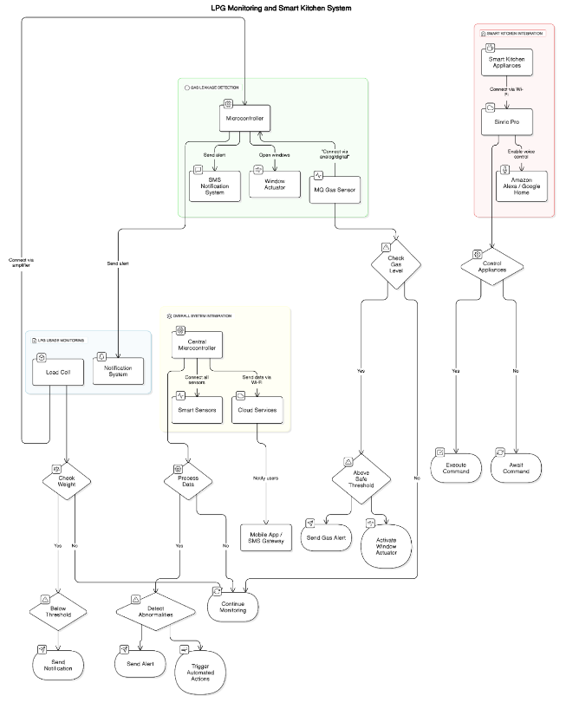

##### Methodology & Implementation

#### LPG Usage Monitoring Module (Using Load Cell)

#### **Components**:

Load Cell: A sensor that measures the weight of the LPG cylinder.

Microcontroller: The microcontroller reads and processes the data from the load cell.

Notification System: Sends alerts to users when the LPG cylinder weight drops below a predefined threshold, indicating that a refill is required.

#### **Connections**:

Load Cell to Microcontroller: The load cell is connected to the microcontroller via an amplifier module (like HX711) to convert the analog weight signals into readable digital data.

Microcontroller to Notification System: The microcontroller communicates with a mobile app or SMS gateway to send notifications. This can be achieved via Wi-Fi or Bluetooth, depending on the setup.

#### **Working Principle:**

The load cell measures the weight of the LPG cylinder. The microcontroller processes this data and compares it to a predefined threshold weight value, which corresponds to the gas consumption.

When the weight of the cylinder drops below the threshold, the system sends a notification to the user via SMS or a mobile app, alerting them that the LPG cylinder needs to be refilled.

#### Gas Leakage Detection Module (Using MQ Gas Sensor)

#### **Components**:

*MQ Gas Sensor: Detects the presence of combustible gases like LPG or methane.*

*Microcontroller: Processes the data from the MQ gas sensor.*

*SMS Notification System: Sends an SMS or app notification if a gas leak is detected.*

*Automated Window Opening Mechanism: An actuator connected to the system opens windows automatically when a gas leak is detected.*

#### **Connections**:

*MQ Gas Sensor to Microcontroller: The MQ gas sensor is connected to the microcontroller through its analog or digital output, depending on the type of sensor used.*

*Microcontroller to Notification System: The microcontroller communicates with the mobile app or SMS gateway to send notifications when gas leakage is detected.*

*Microcontroller to Window Actuator: The microcontroller controls the window actuator, which opens the windows upon detecting a gas leak.*

#### **Working Principle:**

*The MQ Gas Sensor detects the concentration of combustible gases in the air. When the gas level exceeds a safe threshold, the microcontroller is triggered to send an alert to the user through an SMS or mobile app notification.*

*Simultaneously, the automated window opening mechanism is activated to open the windows and allow the gas to dissipate, reducing the risk of dangerous accumulation and potential explosions.*

#### Smart Kitchen Integration (Using Sinric Pro and Voice Control)

#### **Components**:

*Sinric Pro: A cloud-based platform that enables the connection of devices to voice assistants like Amazon Alexa and Google Home.*

*Amazon Alexa / Google Home: Voice-controlled platforms to interact with the kitchen appliances.*

*Smart Kitchen Appliances: Kitchen devices that can be controlled through Sinric Pro, such as lights, fans, and cooking appliances.*

#### **Connections**:

*Smart Kitchen Appliances to Sinric Pro: The appliances are connected to Sinric Pro via Wi-Fi, allowing them to be controlled by Alexa or Google Home.*

*Sinric Pro to Amazon Alexa / Google Home: Sinric Pro acts as an intermediary, allowing Alexa or Google Home to communicate with the connected kitchen appliances.*

#### **Working** **Principle**:

*Sinric Pro connects all smart kitchen devices to the cloud, allowing them to be accessed and controlled remotely via voice commands.*

*Users can issue voice commands to Amazon Alexa or Google Home to control appliances such as turning lights on/off, adjusting fan speeds, or even checking the status of the LPG gas usage.*

*The integration provides a convenient, hands-free way to interact with kitchen appliances, improving user experience and kitchen efficiency.*

#### Overall System Integration

#### **Components**:

*Microcontroller (Central Unit): A central unit that processes data from all modules and coordinates communication between them.*

*Cloud Services (Blynk): Enables real-time data monitoring, remote control, and notifications.*

*Smart Sensors (Load Cell, MQ Gas Sensor): Provides real-time data on LPG levels and gas leaks.*

#### **Connections:**

*Microcontroller to All Sensors and Actuators: The microcontroller is the central hub that connects all sensors (load cell, MQ gas sensor) and actuators (window actuators) to ensure smooth communication and processing of data.*

*Microcontroller to Cloud Services: The microcontroller connects to cloud services via Wi-Fi to send real-time data, such as gas levels or notifications, to users through mobile apps or SMS.*

*Cloud to Mobile App / SMS Gateway: The cloud services interact with the mobile app or SMS gateway to notify users about gas levels, leaks, or other alerts.*

#### **Working Principle:**

*The microcontroller acts as the central processing unit, coordinating data from the sensors (load cell and MQ gas sensor) and sending alerts or control signals to the actuators (window opening mechanism).*

*Real-time data is sent to cloud services like Sinric Pro and Blynk, allowing users to monitor the system remotely and control appliances through mobile apps or voice assistants.*

*If the system detects any abnormalities (such as low LPG levels or a gas leak), it sends instant notifications to users via SMS or the mobile app. Additionally, automated actions like opening the windows are triggered to ensure safety.*

# Software Implementation

### Methodology & Implementation

*The "Recipe Lens" application leverages Django for its robust, secure, and scalable framework, enabling efficient user login and project expansion. Its frontend features a user-friendly interface with options to upload or take pictures, generating recipes based on the images. Data scraping ensures a comprehensive image dataset for training, with tools to download images and extract recipe details from websites. Image encoding transforms images into numerical representations for efficient recognition and recipe generation, storing the results for seamless retrieval and display.*

### Results:

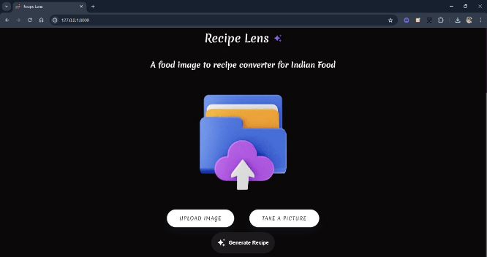

##### 

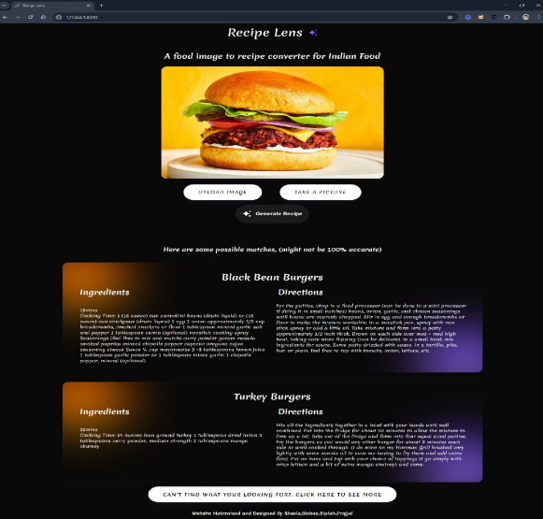

# Conclusions and Future Scope

The Automated LPG Usage and Safety Monitoring System & Smart Kitchen enhances safety, convenience, and efficiency through real-time monitoring, automated safety mechanisms, and smart home integration. IoT-based technologies ensure continuous LPG tracking, instant gas leakage detection, and proactive safety measures like automatic ventilation and emergency alerts. Integration with Blynk and Sinric Pro enables voice-controlled appliance management via Amazon Alexa and Google Home, making kitchens smarter and safer.

Future developments include deeper smart home integration with refrigerators, ovens, and air purifiers, predictive LPG consumption analytics, and automated refill coordination with LPG providers. Enhancements in gas detection for carbon monoxide and methane, mobile app-based remote monitoring, and sustainable energy integration will further improve safety and efficiency.

The Recipe-Lens project will evolve with personalized user experiences, AI-driven meal recommendations, and interactive cooking guides, revolutionizing culinary creativity and kitchen automation. Data analytics from the system could also support smart city initiatives, optimizing urban safety and resource management.

##### References

1. T. V. Tamizharasan, T. Ravichandran, M. Sowndariya, R. Sandeep, and K. Saravanavel, “Gas Level Detection and Automatic Booking System,” International Journal of Scientific Research and Engineering Development (IJSRED.
2. S. Chawla and H. Chawla, “A Comparative Study on Monitoring of LPG Gas Cylinders to Prevent Hazards,” in Proceedings of the International Conference on Smart Innovations in Communications and Computational Sciences (ICSICCS), 2023.
3. R. K. Kodali and S. C. Rajanarayanan, “IoT-Based Automatic Gas Booking and Leakage Detection System,” International Journal of Internet of Things and Smart Technology (IJITST).
4. T. V. Tamizharasan, T. Ravichandran, M. Sowndariya, R. Sandeep, and K. Saravanavel, “Gas Level Detection and Automatic Booking System (IoT-Based),” in Proceedings of the International Conference on IoT and Smart Applications.
5. Gonzalez, R. C., & Woods, R. E. (2018). Digital Image Processing (4th ed.). Pearson.
6. Huang, G., Liu, Z., Van Der Maaten, L., & Weinberger, K. Q. (2017). Densely Connected Convolutional Networks. In Proceedings of the IEEE Conference on Computer Vision and Pattern Recognition (CVPR) (pp. 4700-4708). doi:10.1109/CVPR.2017.243.

Holovaty, A., & Kaplan-Moss, J. (2009). The Definitive Guide to Django: Web Development Done Right (2nd ed.). Apress